Stateless Service
No memory between calls
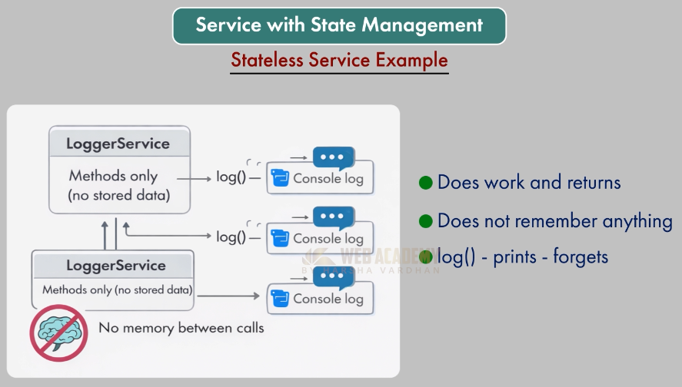

វាមិនរក្សាទិន្នន័យនោះទេ (cannot share data)
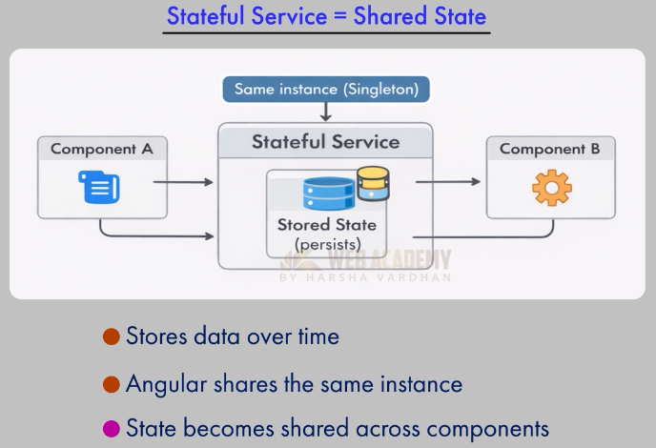

Create Counter to remember the count:
>> ng g s services/counter

import { Injectable } from '@angular/core';

@Injectable({
providedIn: 'root',
})
export class Counter {

}
- Then

import { Injectable } from '@angular/core';

@Injectable({
providedIn: 'root',
})
export class Counter {

private count: number = 0;

}

យើងប្រើប្រាស់ private keyword ព្រោះដើម្បីកុំអោយ component ធ្វើការកែប្រែបាន

- Add the method getCount() and increstment method to count by 1
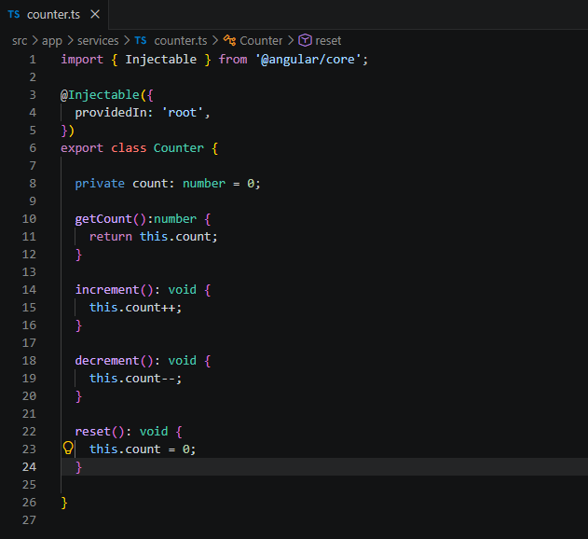

2- Create components to use the service count

>> ng g c counter-display
>> ng g c counter-controls

